**JAVA PROGRAMMING PROJECT**

**Areas completed:**

1 Start menu for Teacher Login, Faculty Login and Student Login

2: Successfully Teacher Login (id: teacher, password: teacher)

3: Successfully Faculty Login (id: admin, password: admin)

4: Successfully Student Login (id: 14832, password: 14832 (for demo))

5: Successfully add marks of student with teacher login

6: Successfully create course plan for student with teacher login

7: Successfully save attendance for student with teacher login

8: Successfully add student and update information with faculty login

9: Successfully add student fees and update with faculty login

10: Successfully add course with faculty login

11: Successfully add course with Student Login (id: 14832, password: 14832(for demo))

12: Successfully see transcripts with Student Login (id: 14832, password: 14832 (for demo))

13: Successfully create course plan with Student Login (id: 14832, password: 14832 (for demo))

14: Successfully see attendance with Student Login (id: 14832, password: 14832 (for demo))

15: Successfully Manage Academic Calendar

16: Successfully Manage Exams, Assignments and Results.

17: Successfully create UML diagram

18: Successfully create readme file

19: Successfully create project report file

**HIGHLITE**

**MAIN MANU:** we can login with three different accounts Teacher, Faculty and Student. Teacher login (id: teacher, password teacher). Faculty login (id: admin, password: admin). Student login (id: 14832, password: 14832 (for demo))

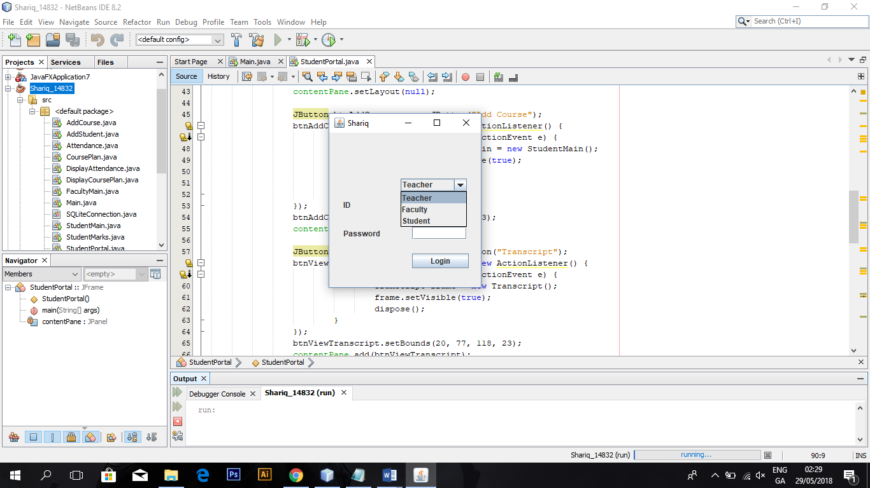

**Teacher:** we can login with Teacher (id: teacher, password: teacher). There are three option is teacher add mark, course plan and attendance.

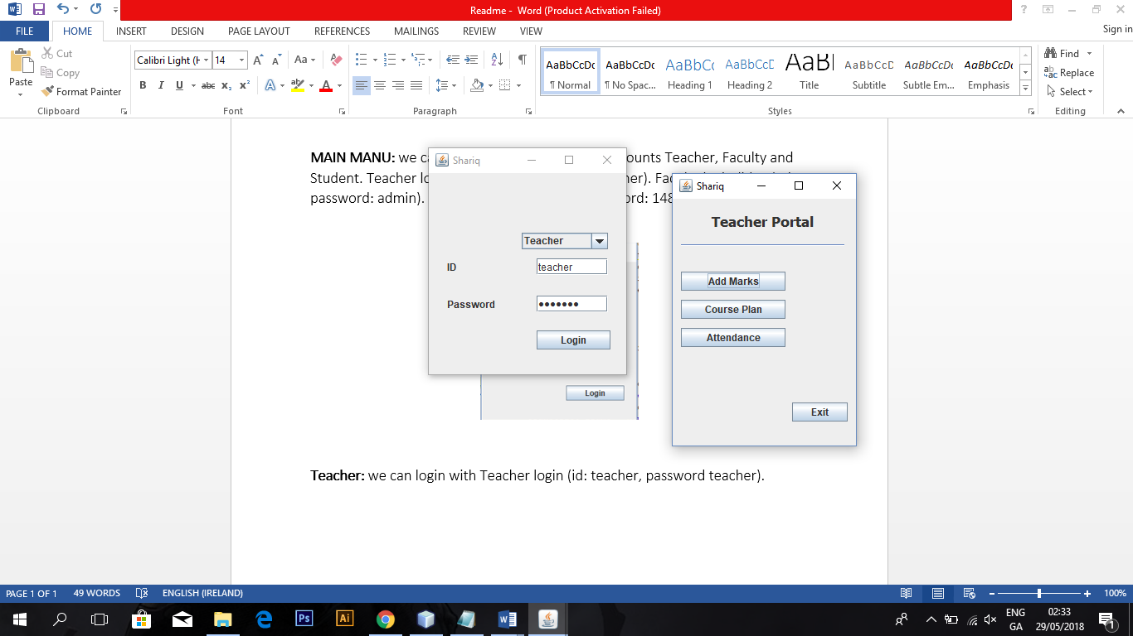

**Faculty:** we can login with faculty (id: admin, password: admin). There are two option is faulty add student and add course.

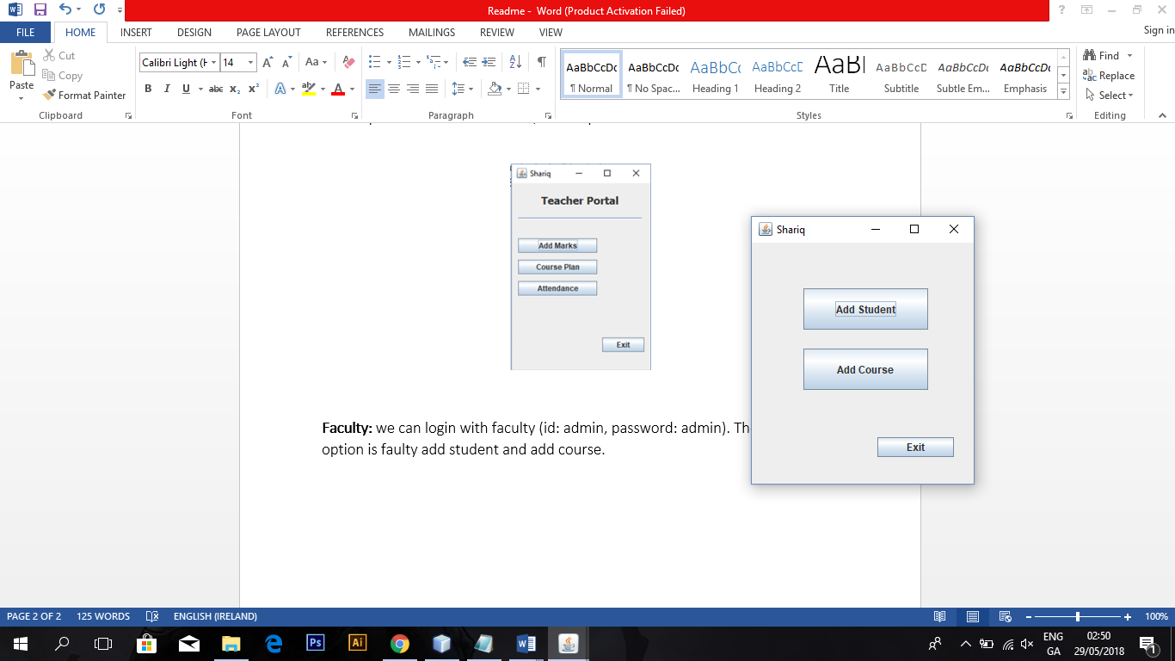

**Student:** we can login with student (id: 14832, password: 14832). There are four option is student. Add course, transcript, course plan, and attendance.

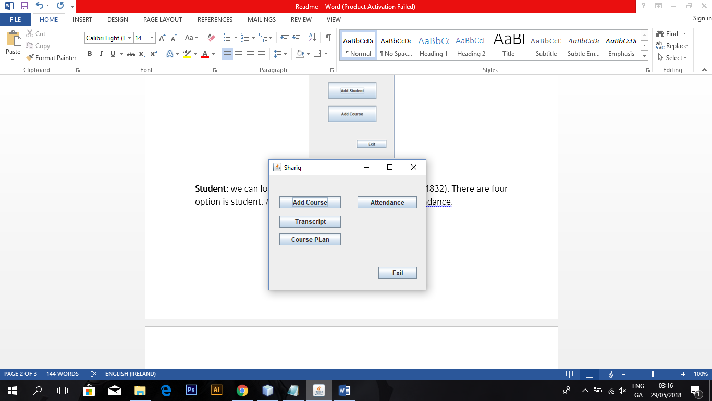

**UML DIAGRAM**

